UNIT TITLE: BIT 4107 MOBILE APPLICATION DEVELOPMENT
Compiled by: Kefa Vincent BIT/2024/54140
PROJECT NAME: Educlear
APPLICATION USED: Android studio
LANGUAGE USED: Kotlin
LECTURER NAME: Mr. Michael Nyoro

Introduction to the Educlear
The EduClear Student Clearance Management System is a mobile application developed in Android Studio using Kotlin and XML layout frameworks. The application is specifically engineered to streamline, digitize, and track the traditionally tedious university graduation clearance process for students and also for high schools during final year.

Project Objectives:
1. Automate the student clearance process
- Replace manual, paper-based clearance with a digital workflow to reduce delays, lost forms, and repeated follow-ups across departments.
2. Centralize clearance status tracking
- Provide students and admin staff with real-time visibility of clearance status from all required departments: library, finance, hostel, academics, etc.
3. Improve communication between departments and students
- Enable instant notifications and updates so students know exactly which department is pending and what action is needed.
4. Reduce administrative workload
- Allow department heads to approve or reject clearance requests within the app, eliminating physical queues and manual sign-offs.
5. Ensure data accuracy and auditability
- Maintain a secure, timestamped record of all approvals and rejections for easy audits and future reference.

Installation Steps
How to download Android Studio
- Open your web browser and navigate to the official developer portal: developer.android.com/studio.
- Click the prominent "Download Android Studio" button.
- Accept the Google Terms and Conditions checkbox to initiate the download.

Steps for installation
• Double-click the downloaded executable file (usually named android-studio-xxxx-windows.exe).
• If a User Account Control (UAC) prompt pops up asking for permission, click Yes.
• In the Setup Wizard, click Next.
• Choose Components: Ensure both Android Studio and Android Virtual Device (AVD) are checked, then click Next.
• Choose your preferred installation location (the default path in C:\Program Files\Android\Android Studio) and click Next.
• Click Install. Once the progress bar fills up, click Next and then Finish to launch Android Studio.
THE SCREENS BELOW SHOW THE STEPS DURING ISTALLATION;

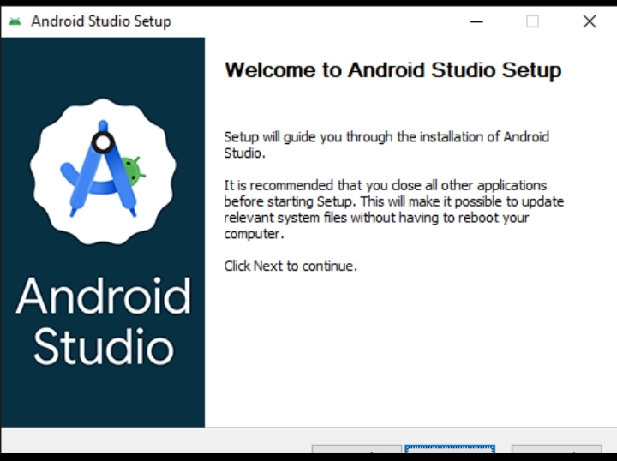
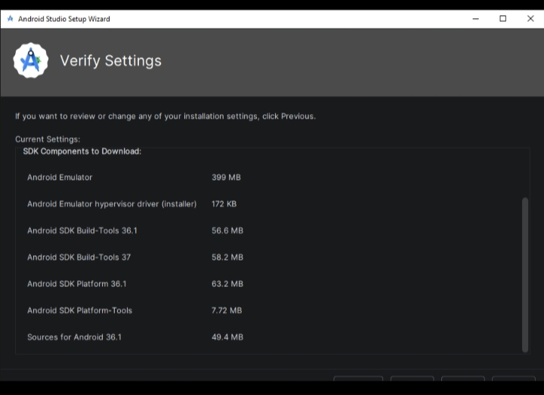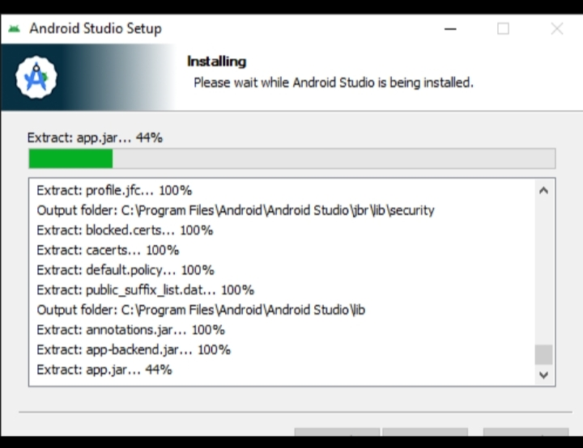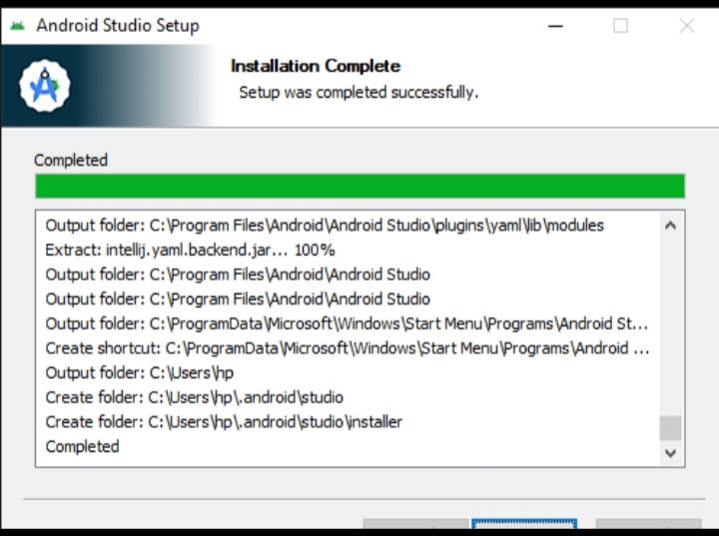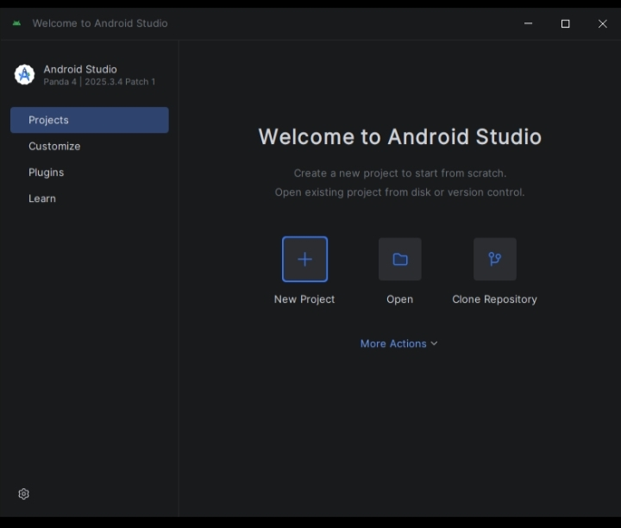
Weekly Objectives
• Establish a robust authentication system supporting multiple login methods (Student ID, Microsoft, Guest).
• Create a centralized dashboard with real-time status tracking for five university departments.
• Implement functional sub-modules for Library, Finance, Sports, Registry, and Hostel clearance.
• Modernize the User Interface (UI) using Material Design 3 principles for a creative and professional look.

Activities Completed
• Authentication Engine: Built LoginActivity with validation logic. Integrated a Microsoft OAuth redirect and a custom email-prompt dialog for new students.
• Dynamic Dashboard: Developed DashboardActivity featuring a "Hero" header, personalized user greeting, and department status cards.
• Department Sub-Modules: Created five interactive pages:
- Finance: Simulation of balance tracking and debt payment.
- Library: Form for book return verification.
- Sports/Registry/Hostel: Data entry and document upload simulations.
• Bottom Navigation: Implemented a global navigation bar with persistent state across the Dashboard and Profile screens.
• Branding & Asset Design: Designed a golden adaptive app icon and a consistent Indigo/Slate color palette.

Challenges Faced
• Theme Mismatch Crash: The app initially crashed when adding modern components (like TextInputLayout) because the theme was set to legacy AppCompat.
• Resource Linking Errors: Experienced "Resource not found" errors after refactoring hardcoded strings.
• UI Layout Issues: Problems with UI elements overlapping on smaller screens, specifically the dashboard header and profile logo.
• Data Persistence: Ensuring the user's login ID persisted and appeared correctly on the dashboard after navigating through multiple screens.

Solutions Implemented
• Material 3 Migration: Updated themes.xml to inherit from Theme.Material3.DayNight.NoActionBar. This resolved the component inflation crashes.
• String Resource Centralization: Performed a project-wide extraction of all text into app/src/main/res/values/strings.xml, fixing linking errors and enabling future localization.
• Responsive Layout Refactoring: Replaced static RelativeLayout structures with CoordinatorLayout and NestedScrollView, and used layout_toStartOf constraints to prevent overlaps.
• Intent Extra Handling: Implemented intent.putExtra("USER_ID", ...) in the login flow and retrieved it using intent.getStringExtra in the Dashboard to personalize the greeting.

Code Snippets
- Dynamic User Greeting (DashboardActivity.kt)
// Retrieve login ID and display personalized message
val userId = intent.getStringExtra("USER_ID") ?: "Student"
tvWelcome.text = getString(R.string.welcome_back_user, userId)

B. Modern Material 3 Button (activity_login_screen.xml)
<com.google.android.material.button.MaterialButton
android:id="@+id/btnContinueMicrosoft"
style="@style/Widget.Material3.Button.OutlinedButton"
android:layout_width="match_parent"
android:text="@string/continue_with_microsoft"
app:cornerRadius="27dp"
app:icon="@android:drawable/ic_menu_compass" />
Testing evidence
FEATURE | TEST CASE | RESULT
Login Validation | Attempt login with empty ID field. | PASSED: Error message "Please enter your Student ID" displayed.
Microsoft Login | Click "Continue with Microsoft". | PASSED: External browser opens Microsoft login portal.
Navigation | Click "Profile" icon on Bottom Nav. | PASSED: Screen switches to ProfileActivity correctly.
Clearance Update | Settle debt in Finance module. | PASSED: Dashboard badge updates from "Action Required" to "Cleared".

Reflections & Lessons Learnt
• Consistency is Key: Using a centralized colors.xml and strings.xml makes large-scale UI redesigns much faster and prevents "hardcoded string" bugs.
• M3 Benefits: Transitioning to Material Design 3 significantly improved the "look and feel" of the app with minimal extra code, thanks to its built-in styling for cards and buttons.
• Modular Thinking: Dividing the clearance process into separate activities (modules) made the project much easier to debug and scale compared to keeping everything on one screen.

